**MarketBasedInsights_phase 3**

import pandas as pd

**loading dataset**

data=pd.read_csv('Naan_data.csv',encoding='iso-8859-1')



**counting number of values missed in each column**

missing_values = data.isnull().sum()

missing_values

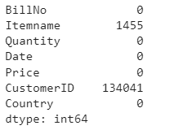

**As more data are missed in customerid, we use interpolate to fill data**

data_cleaned = data.interpolate()

missing_new_values= data_cleaned.isnull().sum()

missing_new_values

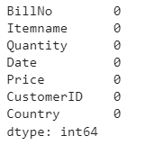

**Now we get missing values in itemname alone, hence we drop rows here**

df_cleaned = data_cleaned.dropna()

**final missing values**

missing_new_values= df_cleaned.isnull().sum()

missing_new_values

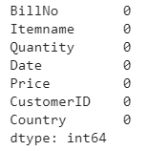

**printing data type of each column**

df_cleaned.dtypes

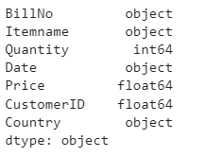

**grouped by country**

grouped_country = df_cleaned.groupby('Country')

grouped_country



Norway_count = grouped_country.size().get('Norway', 0)

Norway_count



**grouped by items**

grouped_items = df_cleaned.groupby('Itemname')

metal_latern_count=grouped_items.size().get('WHITE METAL LANTERN', 0)

metal_latern_count



**grouped by date**

grouped_date = df_cleaned.groupby('Date')

dec1 = grouped_date.size().get('01-12-2010', 0)

dec1



**grouped by customerid**

grouped_id = df_cleaned.groupby('CustomerID')

id1 = grouped_id.size().get(17850, 0)

id1



**rows, columns**

df_cleaned.shape

